**Objective Questions:**

1. **What is the distribution of account balances across different regions?**

**Answer**- There are high numbers of customers account in France, Germany and Spain. So, the account balances are also high in the following order: France, Germany, Spain.

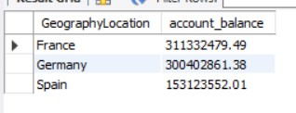

1. **Identify the top 5 customers with the highest Estimated Salary in the last quarter of the year. (SQL)**

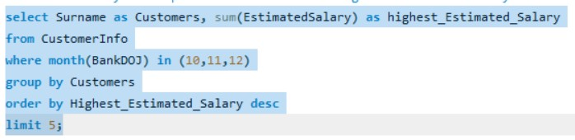**Answer**-

Using this Query we find the top 5 Customers with highest number of transaction are:

* The Walker with 1529153.9 salary,
* Mai with 1377265.46 salary,
* Chu with 1340039.3 salary,
* White with 1244366.77 salary
* Pan with 1146644.1.

1. **Calculate the average number of products used by customers who have a credit card. (SQL)**

**Answer**- According to this SQL Query,

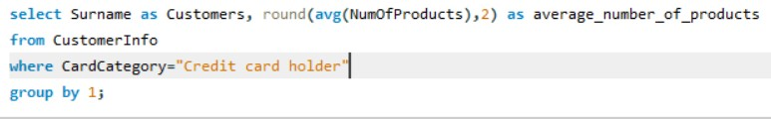

The customers who have credit card mostly use 2 as their number of products.

1. **Determine the churn rate by gender for the most recent year in the dataset.**

**Answer**- According to this SQL Query

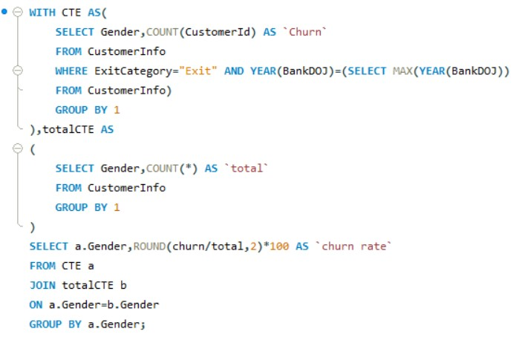

* Male has a churn rate of 5.00
* Female has a churn rate of 8.00.

1. **Compare the average credit score of customers who have exited and those who remain. (SQL)**

**Answer**-Using this SQL code

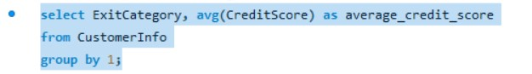

* The customers who have exited has average credit score of 645.35
* Customers who have retained in the bank has average credit score of 651.85.

1. **Which gender has a higher average estimated salary, and how does it relate to the number of active accounts? (SQL)**

**Answer-**

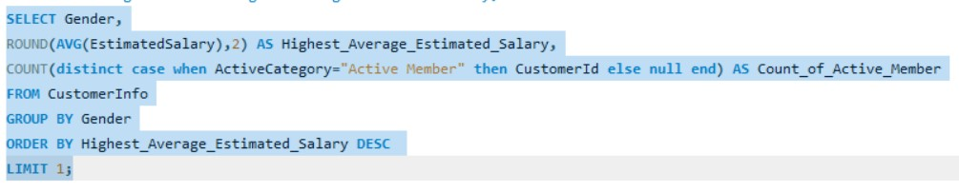

* As we see the Female has highest average estimated salary of around 100601.54 and 2284 is active member even though they are having a smaller number of active accounts than the Male.

1. **Segment the customers based on their credit score and identify the segment with the highest exit rate. (SQL)**

**Answer**-

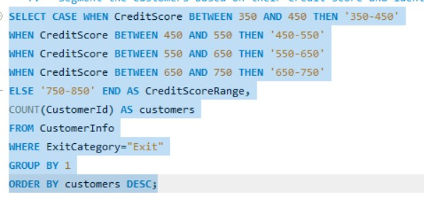

The customer’s credit score has been segmented as:

* “750–850” (Excellent)
* “650-750” (Very Good)
* “550-650” (Good)
* “450-550” (Fair)
* “350-450” (Poor)

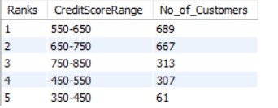

Here We can identify the segment with the highest exit rate in 550-650 Credit Score with 689 Customers.

1. **Find out which geographic region has the highest number of active customers with a tenure greater than 5 years. (SQL)**

**Answer**-

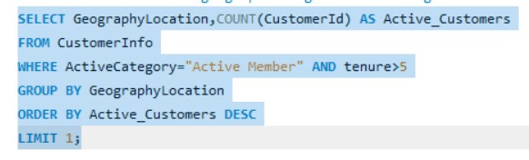

* Using this Query we Find The France is the geographic location which has the highest number of active customers of count 797 with a tenure greater than 5 years.

1. **What is the impact of having a credit card on customer churn, based on the available data?**

**Answer**-

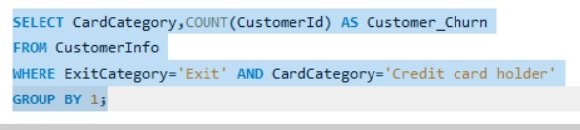

There are 1424 customers have exited from the bank who have credit card. But customers with credit card who remained in the bank is higher than the exited people. So, there is no impact of having a credit card on customer churn.

1. **For customers who have exited, what is the most common number of products they have used?**

**Answer**-

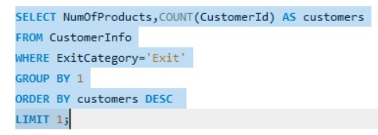

* Total 1409 exited customers have used 1 as their most common number of products.

1. **Examine the trend of customer exits over time and identify any seasonal patterns (yearly or monthly). Prepare the data through SQL and then visualize it.**

**Answer**-

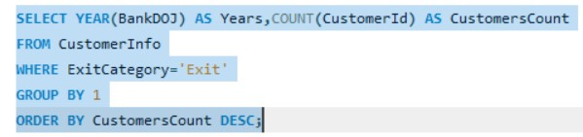

**Using This SQL Query:** According to the given dataset, the most recent year 2019 have the highest exit rate of customers. And also, the outlier is from the year 2016 to 2019 we are losing customers higher when compared to the previous year.

1. **Analyse the relationship between the number of products and the account balance for customers who have exited.**

**Answer**-

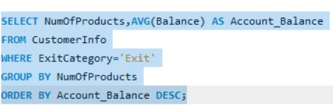

The customers who have 4 as their number of products has the highest average of account balance (93733.14) compared to others followed by one product (92028.82), two products (90252.36) and three products (85853.09).

1. **Identify any potential outliers in terms of spend among customers who have remained with the bank.**

**Answer**- The customers who are not having 4 as the number of products are mostly retained in the bank.

1. **Can you create a dashboard incorporating the visuals mentioned above and additionally derive more KPIs if possible?**

**Answer**- As mentioned above, I have created a dashboard and created some KPI’s such as Average customer balance, Average Credit Score, Average Estimated Salary, Maximum and Minimum of all those categories.

1. **Using SQL, write a query to find out the gender-wise average income of males and females in each geography id. Also, rank the gender according to the average value. (SQL)**

**Answer**-

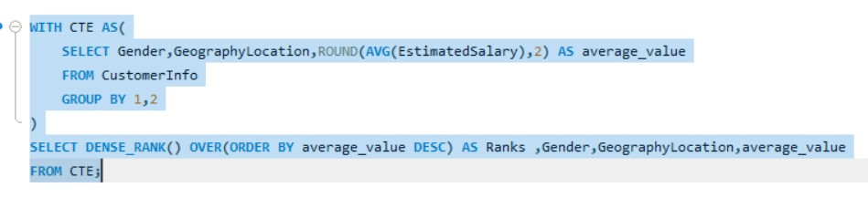By using Dense Rank Function, I have ranked the gender-wise average income of males and females in each geography id.

* First Rank - Female in Germany has average income value 102446.42.
* Second Rank - Female in Spain has average income value 100734.11
* Third Rank - Male in France has average income value 100174.25
* Fourth Rank – Male in Germany has average income value 99905.03
* Fifth Rank – Female in France has average income value 99654.25
* Sixth Rank – Male in Spain has average income value 98425.69.

1. **Using SQL, write a query to find out the average tenure of the people who have exited in each age bracket (18-30, 30-50, 50+).**

**Answer**-

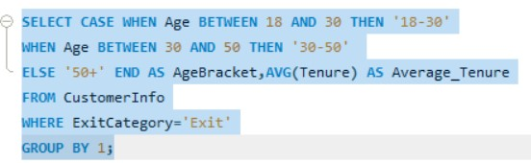

The average tenure of the customers with the age bracket of 50+ is 4.8533 which is the highest average tenure followed by the customers with the age bracket of 30-50 is 4.8765, the customers with the age bracket of 18-30 is 4.8226.

1. **Is there any direct correlation between the salary and the balance of the customers? And is it different for people who have exited or not?**

**Answer**-

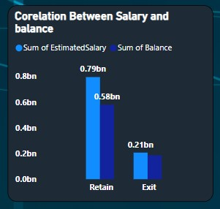

From the above picture, we can get the conclusion as if there is increase in salary for both the retained customers and the exited customers, there is an increase in balance. So, there is a direct correlation between both salary and balance.

1. **Is there any correlation between the salary and the Credit score of customers?**

**Answer**-

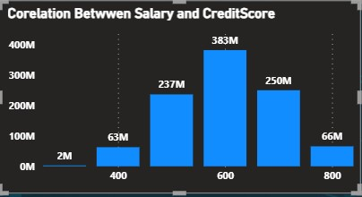

From the column chart mentioned above, we can understand that there is no correlation between salary and credit score.

1. **Rank each bucket of credit score as per the number of customers who have churned the bank.**

**Answer**- I have ranked each bucket of credit score as per the number of customers who have churned the bank in SQL. From that,



1. **According to the age buckets find the number of customers who have a credit card. Also, retrieve those buckets that have a lesser than average number of credit cards per bucket.**

**Answer**- The count of customers with the age bracket 30-50 is 4922 and the count of customers with the age bracket 50+ is 961 and customers with the age bracket 18-30 is 1172. These are all the buckets having lesser than the average number of credit cards per bucket.

1. **Rank the Locations as per the number of people who have churned the bank and the average balance of the learners.**

**Answer**-

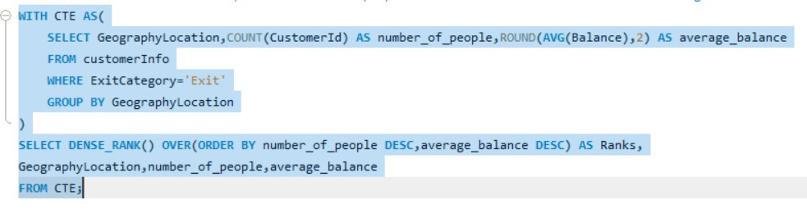

Using This Query found the Output :

* Germany got the first rank because of having 814 number of people and average balance of 120361.08 who exited the bank.
* France got the second rank because of having 810 number of people and average balance of 71192.8 who exited the bank.
* Spain got the third rank because of having 413 number of people and average balance of 72513.35 who exited the bank.

1. **As we can see that the “CustomerInfo” table has the CustomerID and Surname, now if we have to join it with a table where the primary key is also a combination of CustomerID and Surname, come up with a column where the format is “CustomerID_Surname”.**

**Answer**- Using this Quer**y**

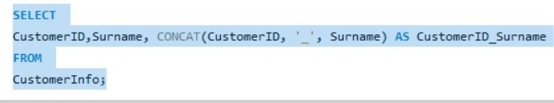

I used this query and get a column where the format is “CustomerID_Surname” show result as table below

. 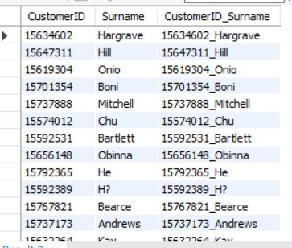

1. **Without using “Join”, can we get the “ExitCategory” from ExitCustomers table to Bank_Churn table? If yes do this using SQL**.

**Answer**- No, Didn’t get because I use only one table for solving above query.

1. **Were there any missing values in the data, using which tool did you replace them and what are the ways to handle them?**

**Answer**- No. There is no missing values in data.

1. **Write the query to get the customer IDs, their last name, and whether they are active or not for the customers whose surname ends with “on”.**

**Answer**-

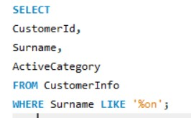

Using this Query I got the Surname end with ‘%on’ , CustomerID and also get to know the Customers is active or not.

**Subjective Question:**

1. **Customer Behavior Analysis: What patterns can be observed in the spending habits of long-term customers compared to new customers, and what might these patterns suggest about customer loyalty?**

**Answer-**

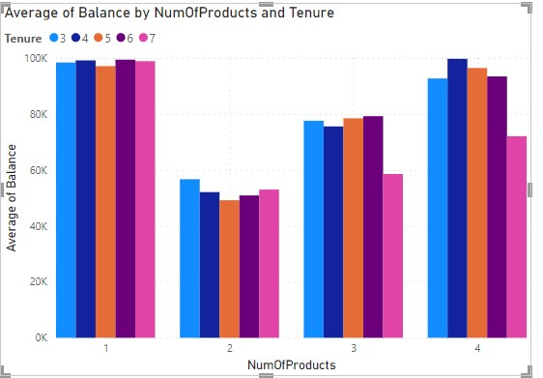

From the above Visualization of graph we can see that spend habits of the retained customers for the long-term customers are lesser than the new customers so that their credit score are also in the lower manner.

1. **Product Affinity Study: Which bank products or services are most commonly used together, and how might this influence cross-selling strategies?**

**Answer-** Here's a general approach to perform this analysis:

Cross-selling strategies : Based on the results, develop cross-selling strategies that leverage the associations between products/services. For example:

* If credit card holders frequently also have saving accounts, the bank could offer targeted promotions for savings accounts to credit card customers.
* If customers with multiple products tend to be more loyal, the bank could incentivize customers to sign up for additional products through bundled offers or rewards programs.

1. **Geographic Market Trends: How do economic indicators in different geographic regions correlate with the number of active accounts and customer churn rates?**

**Answer-**

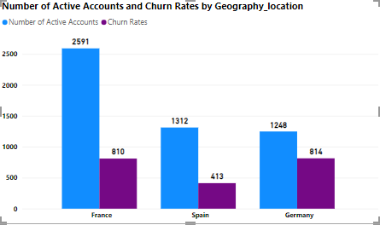

From the above visualisations, we can analyse that the France has the highest number of active accounts and second largest churn rates. On the other hand, Germany has lowest number of active accounts but also the highest churn rates. Spain has the lowest churn rates and second smallest number of active accounts.

1. **Risk Management Assessment: Based on customer profiles, which demographic segments appear to pose the highest financial risk to the bank, and why?**

**Answer-**

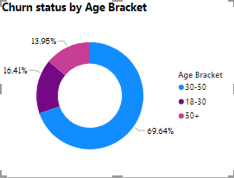

The reason why I choose Age bracket as demographic segment is because age factor is common for both male and female which has high impact on bank’s financial risk. From the above visualizations, middle age bracket people have the highest rate of churn. At the age bracket between 30 and 50, all the people will try to put the investments, but at the time customers are exiting from the bank. It could cause high financial risk to the bank.

1. **Customer Tenure Value Forecast: How would you use the available data to model and predict the lifetime (tenure) value in the bank of different customer segments?**

**Answer-**

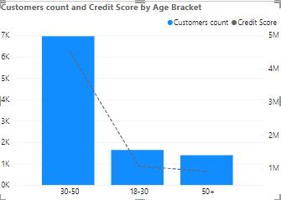

Since the question is asked for the life time value of customer, I have chosen to present the customer count and their credit score for their life time which is age bracket. By this visual, we can understand that credit score for the customer joined at the age of 18-30 will have low credit score since they have just joined. Moving to the age bracket of 30-50, customers are having high credit score which seems to be profitable for the bank. And at the age of 50+, Customers are not ready to spend on banks so that the credit score decreases.

1. **Marketing Campaign Effectiveness: How could you assess the impact of marketing campaigns on customer retention and acquisition within the dataset? What extra information would you need to solve this?**

**Answer-**

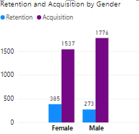

We can say that the acquisition of customer for the last year is higher than the rate of retention for both the male and female. To decrease the retention rate, we may offer some offers on the old customers they could have gain some credit score additionally. So that the new customers also remain for the long period of time.

1. **Customer Exit Reasons Exploration: Can you identify common characteristics or trends among customers who have exited that could explain their reasons for leaving?**

**Answer-**

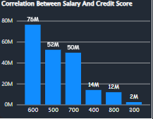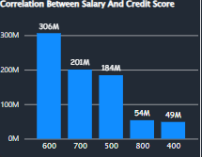

**Exited Retained**

From the above visuals, we can say that the salary and so credit score are the main characteristics or trends among the customers who have exited. Because as the salary is low, they are not able to maintain the credit score. So that they may planned to exit the bank.

1. **Are 'Tenure', 'NumOfProducts', 'IsActiveMember', and 'EstimatedSalary' important for predicting if a customer will leave the bank?**

**Answer-** Yes, Tenure, NumOfProducts, IsActiveMember and EstimatedSalary are important for predicting if a customer will leave the bank. Because these columns will help us to find the customers can buy product with his estimated salary and can settle down the payment within the tenure time and after paying things will he be available as active member in the bank.

1. **Utilize SQL queries to segment customers based on demographics and account details.**

**Answer-** Using this Query:

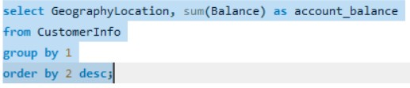

And Output Are:

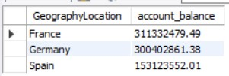

This is The Account balance details based GeographyLocation.

1. **How can we create a conditional formatting setup to visually highlight customers at risk of churn and to evaluate the impact of credit card rewards on customer retention?**

**Answer-**

|  |  |  |
| --- | --- | --- |
| **Credit Card Status** | **Churn Status** | **Count of Customer Id** |
| **Credit Card Holder** |  | **7055** |
|  | Exit | 1424 |
|  | Retain | 5631 |
| **Non-Credit Card Holder** |  | **2945** |
|  | Exit | 613 |
|  | Retain | 2332 |
| **Grand Total** |  | **10000** |
|  |  |  |

In this, we can select the count of Customer Id column an select the conditional formatting which is present in the home tab. In that we can format things according to that data by the MS Excel.

1. **What is the current churn rate per year and overall as well in the bank? Can you suggest some insights to the bank about which kind of customers are more likely to churn and what different strategies can be used to decrease the churn rate?**

**Answer-**

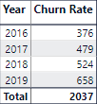

Current churn rate we can say that 658 for the year 2019 which is current churn rate per year. And the total churn rate is 2037. The age bracket of 30-50 has the highest percent of churn rate. For those people, we can give some extended tenure period so that he could able tackle his issue by the extended time.

1. **Create a dashboard incorporating all the KPIs and visualization-related metrics. Use a slicer in order to assist in selection in the dashboard.**
2. **How would you approach this problem, if the objective and subjective questions weren't given?**

**Answer-** If the specific objective and subjective questions weren't provided, I would approach the problem of risk management assessment and customer retention in a more general manner. Here's how I would approach it:

* **Data Explore**
* **Data Collection & Analysis**
* **Segmentation**
* **Risk Assessment Model Development**
* **Feature Importance Analysis**
* **Intervention Strategies**
* **Monitoring and Evaluation**
* **Iterative Improvement**

By following this approach, businesses can proactively identify and manage risks associated with customer churn, ultimately leading to improved customer retention and long-term profitability.

* Top of Form

1. **In the “Bank_Churn” table how can you modify the name of the “HasCrCard” column to “Has_creditcard”?**

**Answer-** To modify the HasCrCard column to “Has_creditcard we can use SQL query:

ALTER TABLEBank_Churn

RENAME COLUMN **HasCrCard to Has_creditcard;**